
EPIC Performing Company
2026-2027 Handbook

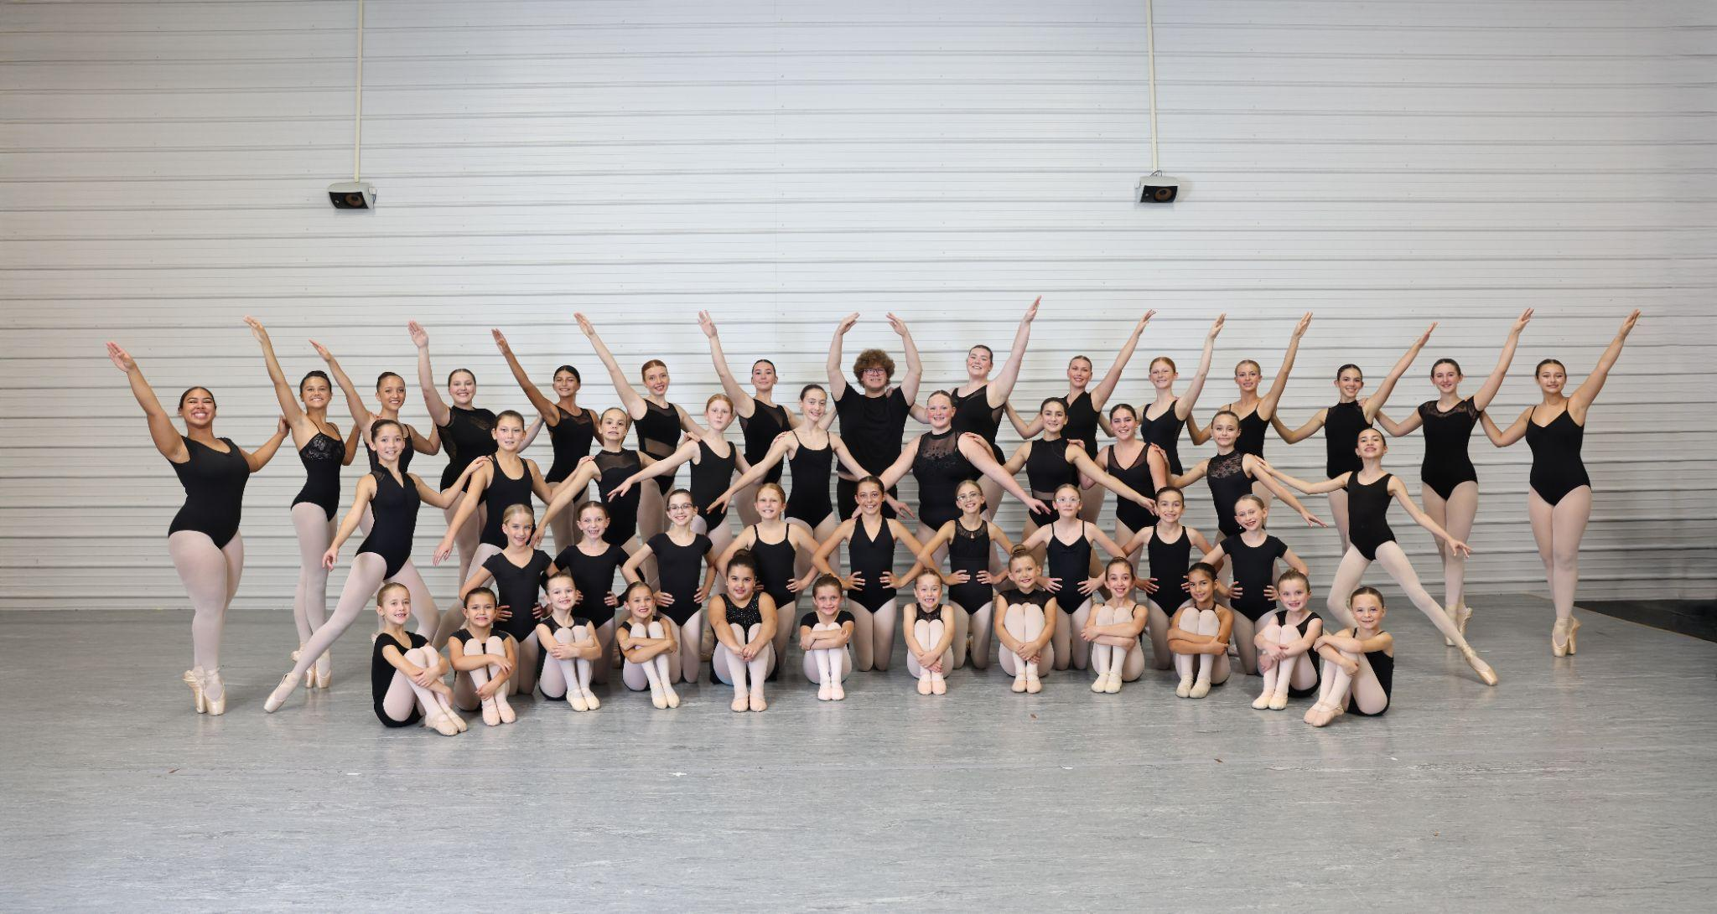

EPIC History
EPIC was founded in the fall of 2016 and began small with simple community outreach performances. Now moving into its ninth year, EPIC has become a nonprofit performing company that includes an annual Holiday Showcase, a competition team, and performers that continue to give back to their community. We are always looking for new and exciting performance opportunities for our dancers. EPIC dancers have been lucky enough to travel four times to Disney World to perform at the Disney Springs stage and become honorary cast members!

Our Mission
To provide high quality dance instruction with unique performance opportunities in a healthy and fun environment.

We would like to personally welcome new and returning members to our company!

Membership Fee What’s Included?
$150 | - 1/8-page ad in Holiday Showcase program  - costuming for Nutcracker/ group competition pieces, theater rental, & prop rentals  - performance opportunities

Attendance & Punctuality

Performers must attend every Thursday EPIC rehearsal and arrive, unless already in class, 15 minutes prior to warm up. Attendance is mandatory the Thursday prior to any performance on the weekends in September and with group rehearsals the month October. This will consist mostly of half day Saturdays and this year possibly some Fridays. If you have a rehearsal on a Friday, you likely will NOT have a Saturday rehearsal. We cannot stress the importance of warming up prior to any rehearsal enough. We ask that you make us aware of any planned vacation as soon as possible after auditions.

Performer Obligations

- Dancers must take ALL ballet classes offered in your dancers level a week. If a dancer is not a full time member of the studio, they must take, at minimum, ONE En Pointe Ballet Class.
- Dancers must perform in the Holiday Showcase in November (weekend before Thanksgiving) - tentative dates: Friday, November 20th & Saturday, November 21st with a MONDAY, November 16th dress rehearsal
- Dancers must attend Thursday rehearsals
- Dancers must attend September/October rehearsals with show run throughs as needed in November prior to the show
- Dancers must be placed in Ballet Level 2 class or higher
- Dancers must attend as many outreach programs as possible
- Dancers need to plan to expect extra rehearsals closer to performances
- Dancers are expected to have high attendance in their classes. Failure to have multiple absences will result in expulsion of a dancers’ role.

Parent Obligations

- Responsible for a print ready ad for every dancer ad and/or business ad – ads will not unless you opt for the ad creation.
- Encouraged to volunteer for fundraising committees, ticket sales, flower sales, pointe shoes sales, and lobby set up*
- Search for community outreach events*

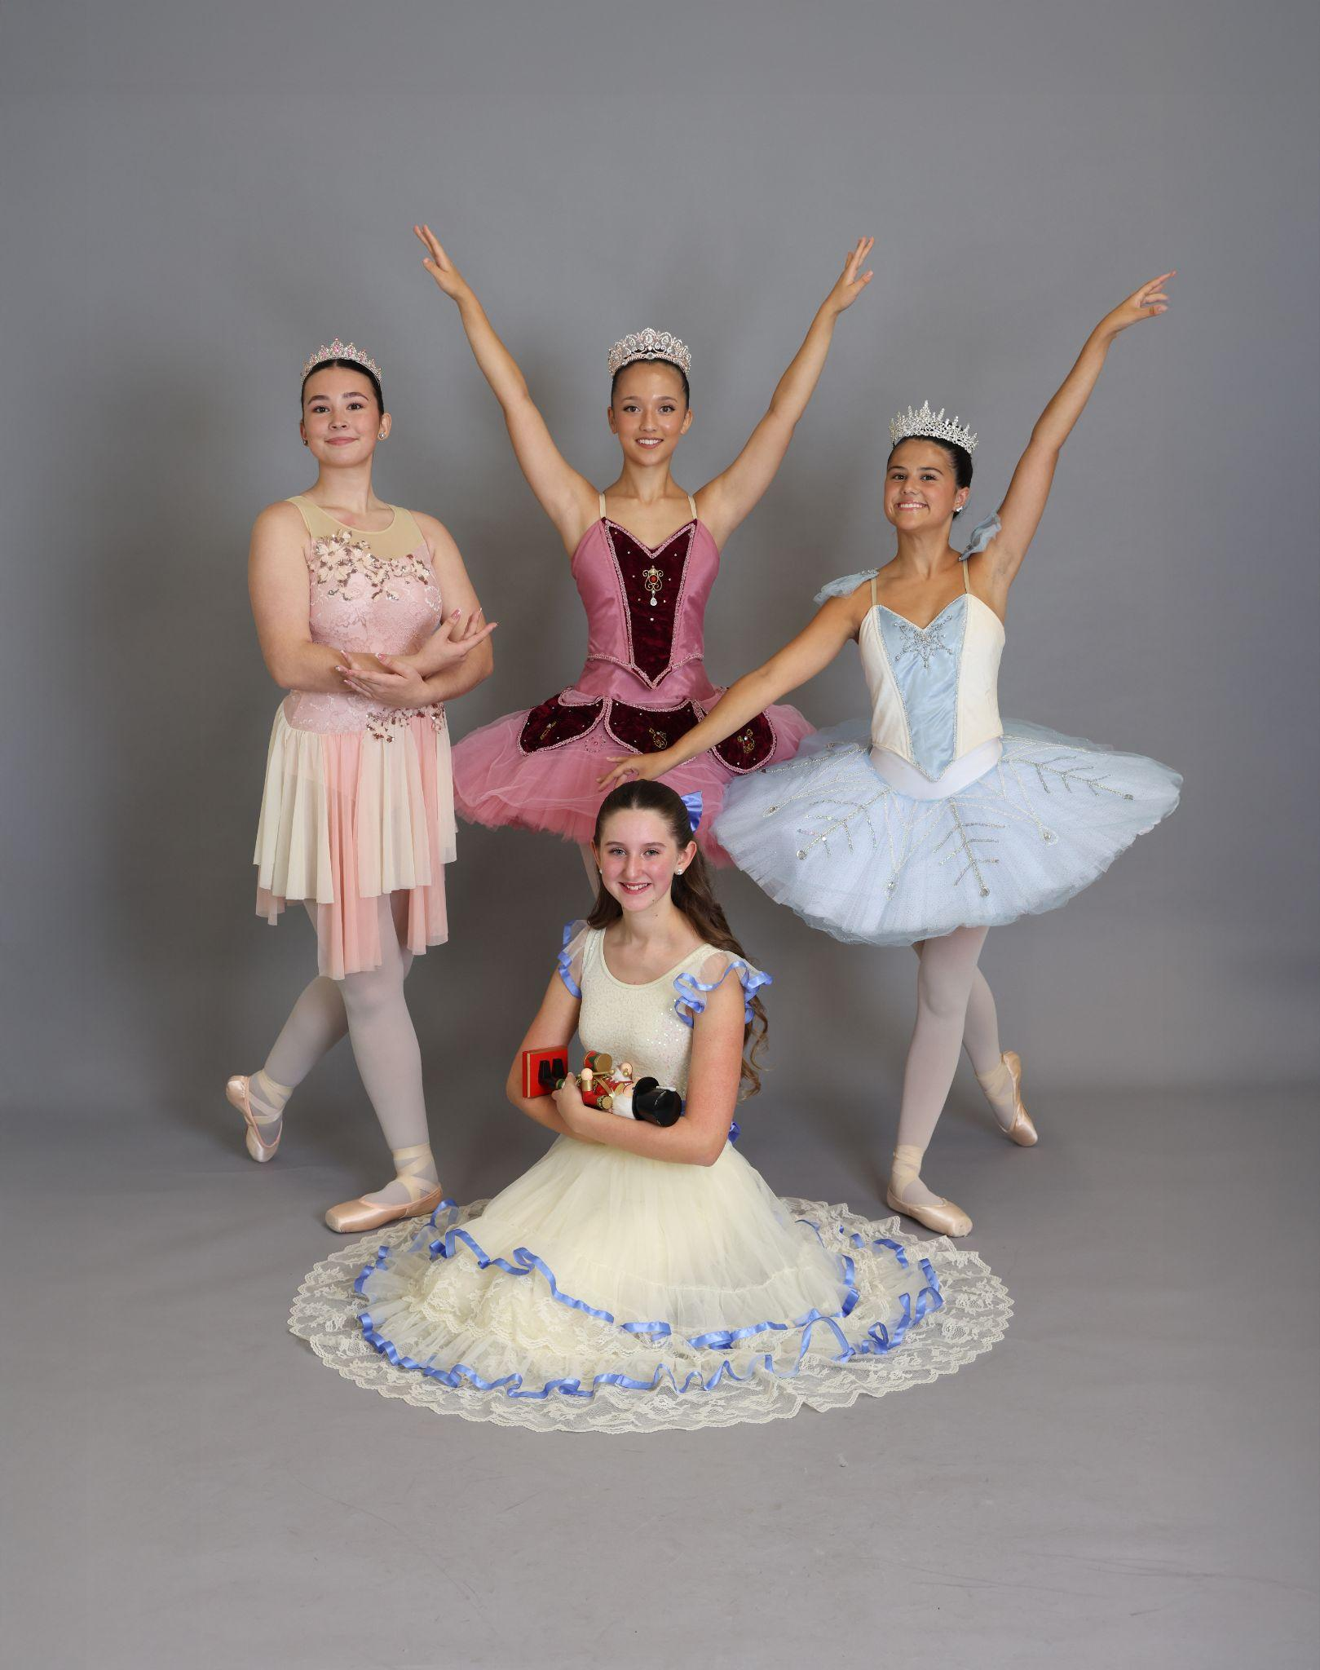

Annual Convention

TBD

What to Expect:
- Convention workshop/competition fees will be due 1.5 months before schedule convention
- Workshop classes Saturday & Sunday 8-3
- Competition pieces will be filmed and submitted

Workshop Tuition Rates*
Ages 8-18 | $300
Observer Pass | N/A

Competition Fees*
Solo | $145
Duo/Trio | $75
Group | $55/per dancer

*these are all approximate costs

A fee will be charged for anyone who wants to do a solo, duo, or trio that is not assigned by choreography staff

Rehearsals:
Rehearsals will be held throughout the week and most likely on Friday afternoons/evenings and Saturday Mornings - rehearsals time and days will be determined by the choreographer. Dancers will be selected by the choreographer for each dance. Rehearsals may be added when needed.

Communication of Information

Email
Information directly relating to the Company will be emailed from the directors only. We ask that you provide ALL emails you would like on the group list. We will work with an ongoing Google doc so all information can be found in one place.

Facebook
As needed, information will be posted on EPIC Performing Company’s FB account. This information will pertain to any last minute changes, weather updates, etc.
Website
To the best of our ability, all information will be located on a tab on En Pointe Studio’s website. This will contain basic information such as calendar of events, rehearsal schedules, show information, etc.
Cell Phone
For our senior company members, we will be relying on them at times to relay information to the parents. This will include rehearsal changes, performance call times, event information, etc.
Cork Board/Dry Erase Board
Information for each upcoming Thursday will be posted on these boards.

Common Dancer Needs
Female
- Black leotard
- Black leggings
- Nude leotard
- Pink, nude, & black tights
- Ballet slippers, nude jazz shoes, pointe shoes*, tap shoes*, lyrical half shoe*
*only applicable for dancers involved in particular dances*
Male
- Black and white shirts
- Black pants
- Black ballet slippers, tap shoes*, nude jazz shoe
*only applicable for dancers involved in particular dances*

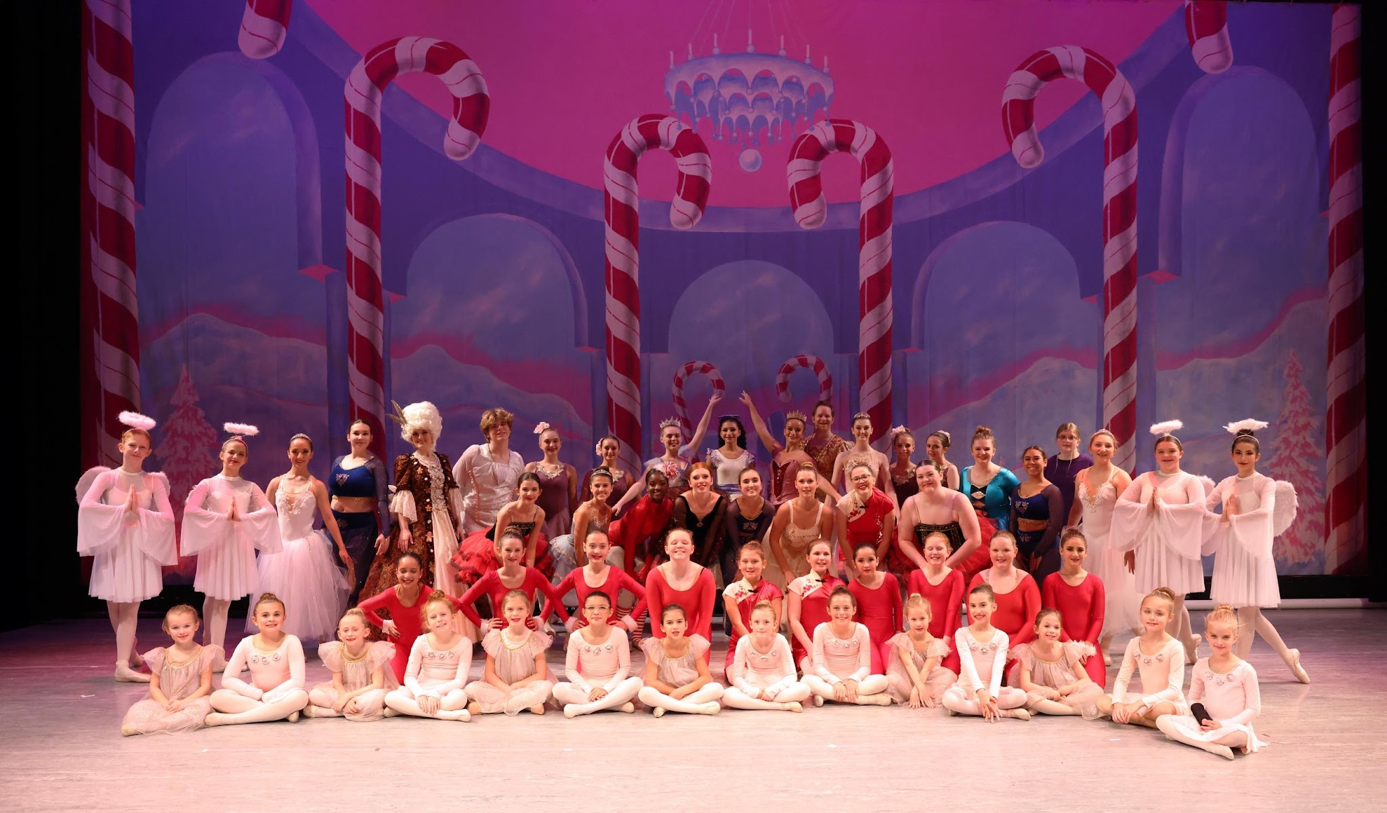
Photo credits: Amber Kopp Photography

